The “Hands Free” Control Helmet

Robert

Brandon

Harrison

Table of Contents:

* Abstract………………………………………………………………...Page 3
* Introduction……………………………………………………………Page 3
* Methodology…………………………………………………………...Page 6
* Flow Chart……………………………………………………………..Page 8
* Block Diagram…………………………………………………………Page 9
* Bill of Material/List of Components………..………...……………...Page 11
* Scheduling/Gantt Chart……………………………………………....Page 14
* Design Process………………………………………………………..Page 15
* Expected results……………………………………………………....Page 17
* References……………………………………………………………Page 18

EENG 489-W01

Professor Farajidavar

Due: 12/16/2022

Members: Brandon Hernandez, Robert Maksimowicz, Harrison Burkoff

Title: The “Hands Free” Control Helmet

Abstract:

There have been many solutions to the issue of safe cycling measures via helmet design, especially at night. Many of these solutions have well thought out designs and perform well too. But one flaw that all of these solutions have is a lack of a completely hands free system. Most systems that already exist within today's market utilize signaling control via a remote mechanism or via a physical interface on the helmet such as buttons. These systems involve a different form of muscle memory to be learned and thus could lead to a higher chance of miss input. The ideal system should work as a hands free, (and as much as possible) a thought free implementation.The exact implementation of this form of system has not been yet developed and what we hope to achieve is to successfully produce a safety helmet for cyclists that is completely hands free and intuitive, so that the rider does not need to gain any form of new muscle memory nor having to remove a single finger from the handle bars. Less overall distraction can lead to a decrease in overall incidents. Along with our signaling method we wish to also implement other safety precautions such as running lights for evening riding as well as environmentally friendly ways to source power such as solar for constant charging during the day time. Also, we wish to implement a brake light feature as well for additional external awareness. Our methodology for going about such a task includes utilizing sensors to be able to read movement such as “head tilt”, in order to activate a signaling mechanism. Along with this we plan on integrating other currently used designs in order to create a helmet not only unique to our own but offers a feature that the others cannot provide. By utilizing an IMU, or an “Inertial Measurement Unit '', we have the ability to program the helmet to be able to detect its degree of tilt from an origin. So, when tilting one's head either left or right, the sensor will be able to read and measure this angle to then activate an LED, in other words our signal blinkers. Additionally, the IMU may be programmed to detect any sudden shift in motion, allowing us to set any sudden jolt forward that can trigger the rear LED acting as a brake light to warn rear coming traffic.

Introduction:

Within New York City alone, efforts are in process to reduce bicyclist fatalities and serious injuries. One of the first assessments of accidents involving bicyclists was started in summer of 2005 in the form of a joint study by the Department of Mental Hygiene (DOHMH), Department of Parks and Recreation, Department of Transportation (DOT), and New York Police Department (NYPD**)**. These efforts are kept up in a record annually kept discussing all Bicycle Crash report data every year, where we see data separated down to the borough [1]. There’s also now a branch left to procuring all of the data and analyzing it, being the child organization of the Department of Transportation, The National Highway Traffic Safety Administration (NHTSA). They compile the statistics and make figures for determining the time of day of most accidents and the main cause [2]. The first study mentioned however published in September of 2006 went by the name of *Bicyclist Fatalities and Serious Injuries in New York City: 1996-2005* and details accidents involving cyclists in various months and times of day [3]**.** This allowed a light to shine on potential issues and proposed action steps to decrease the number of bicyclist fatalities. The subsequent efforts were then compiled into a report published in the “Public Health Reports” in October of 2008, entitled *A Multiagency Effort to Reduce Bicyclist Fatalities and Serious Injuries in New York City* [4]. The efforts that were put into place were used to promote and to increase the safety of all bicyclists in New York City (NYC). All of these action steps were organized within 5 areas of identification in the report: (1) Bicycle Infrastructure, (2) Motorists and Bicyclists Awareness, (3) Investigation and Enforcement, (4) Legislation, (5) Improvement of Data Collection, Analysis, and Reporting. This led to the testing of various methods to increase safety and the completion of “68 miles worth of bike-lane designs”. As much as these measures have helped, it cannot be denied from the study of *effectiveness of bicycle safety helmets* that cyclists that wore helmets had 88% less risk of brain injury [5]. In expansion of the previous ideas, the article by Dan Roe “what’s really killing New York's cyclists” had a used the data collected from the Department of Transportation to conclude the conditions where the most deaths happen [6], The results of this study is further backed by results seen from a similar paper updating the statistics of the bicycling accidents in New York City[7]. In most cases, drivers are usually at fault for killing New York’s cyclists and the best solution becomes one where bicyclists and vehicles are separated via bike-lanes that have physical spacers. However, this is highly impractical considering public pushback from the people of New York and the politicians who oppose them. This leads to a line of questioning that takes into account the background and parts of the inaction and considers ways that bicyclists can remain safer on the road, especially with more than 2 million drivers in New York City. Another significant form of action that can be taken is having some sort of running indicator or light overall on the bicycle as it increases the visibility of it to other drivers and riders. Statistically speaking, a running light on the bicycle decreases “the incidence rate, [for] all recorded bicycle accidents with personal injury… [as] 19% lower for cyclists with permanent running lights mounted; indicating that the permanent bicycle running light significantly improves traffic safety for cyclists.” [8]. An important factor to take into consideration as well is the rise of new cyclists on the road with the expansion of New York City’s “City bikes” for rental commonly found when walking around. These bikes as well as new “E-bikes'' are on the road and available for purchase, boasting easier control and ease of use than a normal bicycle as they assist riders. There is also the vision created by the “Big Jump Project” which stands to make big streets have standalone bike lanes to allow more separation between cars and bicycles, allowing for more accessibility into the practice of riding a bicycle in New York City [9].

This leads into the fact that consumerism is a big part of culture, and whenever faced with a problem a solution will be developed. The problems that bicyclists face are ones that can be mitigated through products readily available on the consumer market since many injuries are related to lack of protective gear. Helmets are especially important and reduce the risk of brain injury heavily given that falling off of a bicycle is rather common. Bicycle helmets despite being helpful for the riders safety might have room for innovation to allow the drivers a way to see them while driving. Some of these products are ones that improve the visibility of the cyclist and allow the intent of the cyclist to be seen via turning signals. Examples of a few to explain are smart helmets from Lumos, Faro, Livall. There was a good comparison of all of these helmets by Sports Journalist Kevin Glenton, he describes the features and then some, The Lumos Ultra Smart Helmet with front and rear lights, a remote control, smartphone compatibility, and it has both brake lights as well as turn signals. This design has very similar features to the helmet we are designing, but our helmet also has a solar panel to recharge while riding. The second design described is the Unit 1 FARO smart helmet which comes with the features of the Luma Helmet, while adding an emergency call feature in case you fall and land on your head. The LIVALL bluetooth helmet has only rear lights and has a microphone and in helmet music controls to allow for hands-free calling and SOS emergency contact calling [10]. However, the main issue with all the previous helmets is that they are not entirely hands free and also require to be plugged into an outlet to charge. In all of these helmets in order to operate the turning signal or lighting modes you need to take your hands off of the handles and press a button, taking away some control of the bicycle for a short time frame. We took all these features and criticisms into consideration and made one with the same basic features as the Luma Helmet and tried to address the issues. This means that it will have the identifiability on the road and address the issue of having to let go of a handle to indicate a turn. This helmet has an IMU unit to serve as a way to activate a turning signal without requiring the user to take their hands off the handles and entirely stay in control. It also has the usage of a solar panel to allow for an environmentally friendly way to charge the helmet throughout the day if you use it.

A major selling point for people cycling more is the environmental benefits that it can bring. Cars and buses can generate a large amount of CO2 not only in everyday use but in production as well. According to the European Cycling Federation, the production of a car can account for 42 grams of CO2 per kilometer and 271 grams of CO2 per kilometer on average when driving. Buses, even though they have much longer life cycles than the average car and can carry many more passengers, it will only produce about 100 grams of CO2 compared to cars [4]. Cycling can bring these emissions down to a minimum with no fuel, no exhaust, no combustion. The production of a bicycle only emits 5 grams of CO2 and then you must factor the human carbon emission. With the average european diet, a person can produce around 16 grams per kilometer cycled totalling to 21 grams per kilometer per bicycle [4]. This is ten times less than the average car and can be improved further with more energy efficient diets to reduce human emission. Our helmet, beyond the carbon emitted during its manufacturing, now has electronics attached and that must be factored in a negative way since it will only increase the carbon produced due to charging. However, we have implemented a solar charging pad to our design which can harness energy from the sun instead of the wall. Allowing charging all the time as long as the weather permits will significantly reduce the need for carbon produced charging; thus, hitting much closer to that 21 gram per kilometer emission rate and being more safe.

Methodology:

Before we discuss more about the helmet it is important to go over what an IMU does and what it is capable of. An IMU is a “device that typically consists of gyroscopes to measure and report angular rate and accelerometers to measure and report specific force.” [11]. These devices can be used with code libraries such as “imucal” and “imumaths” for python which is a popular library that is still updated to keep up with new IMU’s on the market. This package for python allows a way to calibrate for 6 degrees of freedom (DOF) on an IMU [12]. This is what allows us to make note of movement and the direction in a 3d space by using an accelerometer and gyroscope. This will be how we go about making a “hands-free solution” to the problems above.

This leads us to our solution to help out in the efforts listed above in the form of a “Hands-free” LED illuminated helmet. This helmet would have the ability to use turn signals and brake lights included on the helmet via an IMU to allow the user to remain in complete control of the bicycle and have both hands on the handles at all times. Utilizing an IMU’s gyroscope and accelerometer, we would be able to make turning signals and braking signals that automatically trigger upon head tilts or just slowing down on the bicycle. This is to integrate the features most similar designs have, and improve upon it with a way to control a turning signal with a natural action such as a ‘head tilt’ to allow riders to keep their hands steady on their bicycle for turning. The other huge draw towards our solution is a solar panel which allows for a feature none of the other helmets have, this is daytime charging. This feature allows the rider to use the helmet from morning to night. The total list of features that will be implemented are “hands-free” turn signals and brake lights, solar daytime charging for prolonged battery life, front facing led for improved nighttime visibility, as well as app compatibility. The overview and design of the final app can be seen below in Figure 1.1, This shows how the last version of the app ended up looking. What we had to look for was a way to make an app that would fit our goals and purpose. The goal of this app is to create a platform to support the features we want included in our product. An app such as this would provide features that would make our app have competing features with the current helmets on the market. The platform we will be developing for is IOS, this is because everyone in the group uses an Iphone, making it necessary for us to test using the IOS platform. This would ordinarily prove difficult, but since we are utilizing arduinos, there are apps for supporting connectivity to arduinos. We ended up stumbling upon ArduinoBlue as it was also available to be used with IOS phones and had much more documentation available than the other similar apps on the market.ArduinoBlue also had explicit statements of supporting our bluetooth module in question on the description, HM10, and ease of design for the applications use case with adding buttons and sliders.

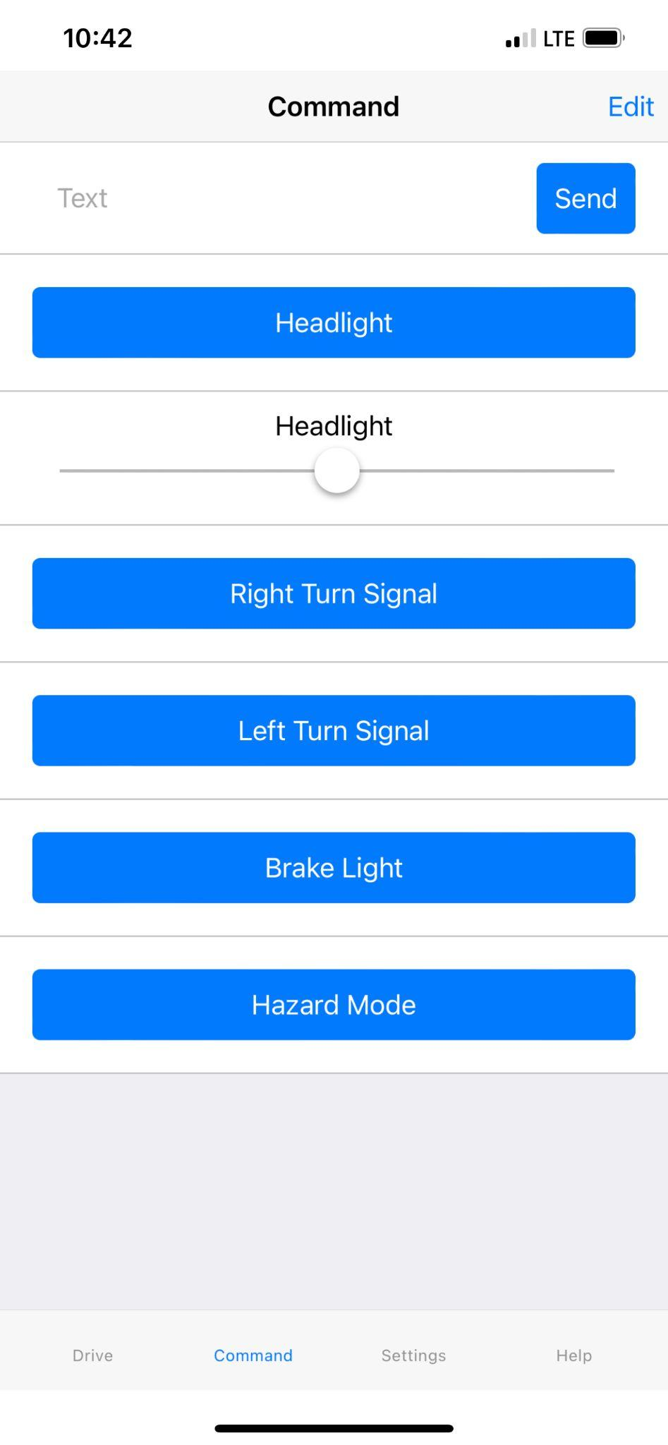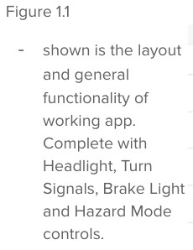

The features as a whole can be seen on Figure 1.2 in the block diagram below to see where all of the components and features will be on the helmet physically. The app gives analytical data such as battery life, helmet synchronization, and brightness of the LEDs. The Flow diagram below in Figure 1.3 showcases how the app connects to the microcontroller on a software and compatibility level as well as how the modules and sensors overall connect to the microcontroller. The program in use to control our microcontroller will be AudrinoBlue. This software is a mobile iOS/Android compatible “app” that can thus operate over bluetooth low energy or BLE [1]. This programming environment will allow us to design a simple-easy to-use phone app, to control our Audrino with buttons, sliders, and joysticks. For example, a slider can be adjusted to increase or decrease the brightness of the LEDS. With a bluetooth module hardwired to our microcontroller, our “HM-10” for power and data transfer, the app will be able to take control once paired. Below Figure 1.3 we see a diagram but with more detail as to which components are being used.

To describe the flow of operation, it is expected to function as follows. Data from the IMU will be inputted into the microcontroller where a program will look at the 6 axis gyroscope data. The microcontroller will then look to determine, with angular thresholds, if the rider is tilting their head for a left or right turn signal, then also look at the deceleration of the rider to determine a braking scenario. These two actions would be displayed on sections of an individually addressable LED strip that is full RGB. This will allow a halo like ring around the helmet to be sectioned off for a yellow left or right signal and a rear brake light. Since the halo wraps around to the front a section of the LED strip will be used to light the path ahead by sectioning a part to light up white and function as a headlamp feature. This headlamp will be manual with the ability to be able to be automatically controlled by using the voltage at the solar panel to determine ambient brightness and determine if additional lighting is necessary for the rider. As mentioned before a smartphone application will communicate with the microcontroller to check battery level and adjust strip brightness. It would also be useful to have manual control when necessary by overriding the IMUs input data with the controls inputted through the smartphone. This can be useful to have a pre-ride check to see if all LEDs are functioning correctly and the desired brightness is achieved for each section..

As for a general standard for bicycle helmets, our product should comply with all standards including the following. Since March 10th, 1999, congress has implemented the CPSC Standard which states that our helmet can withstand a drop of 2.0 meters on a flat anvil and 1.3 meters on a curbstone anvil with a 300 gram failure threshold [7]. Also, this standard calls for limitations on lead and phthalates. Our product should meet all of these requirements since the helmet we sourced is already certified under these regulations. Although, we can not guarantee the success rate for the functionality we are implementing onto the helmet because the electronic components may be damaged after an impact. However, the helmet itself is guaranteed to protect the user up to said standards. A more robust packaging of our system may be an improvement to implement within an updated revision.

Flow Chart:

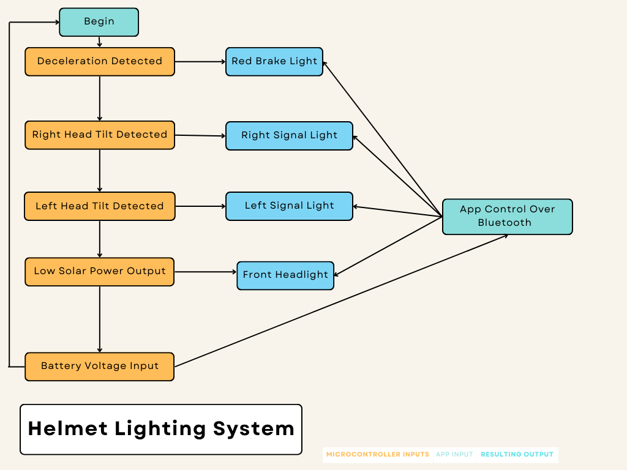

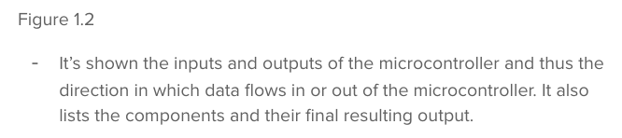

Basic Block Diagram:

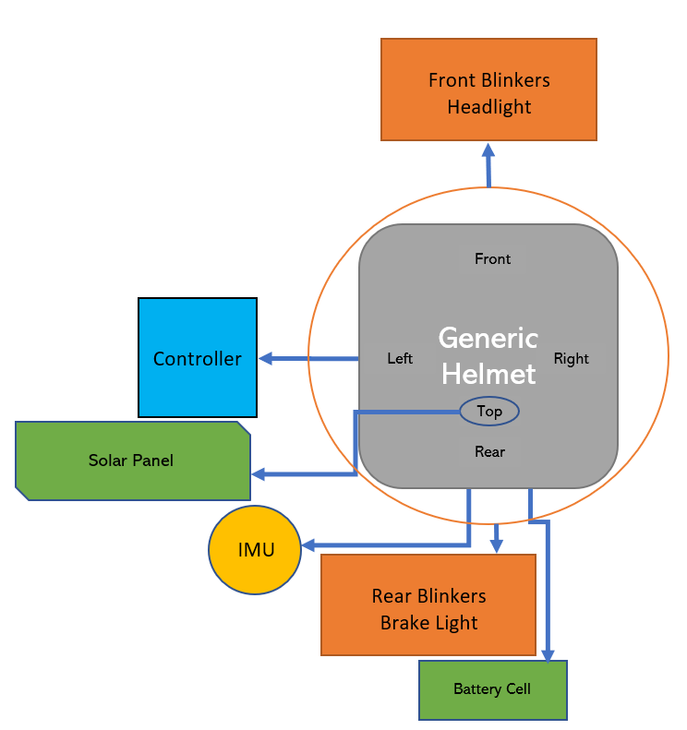

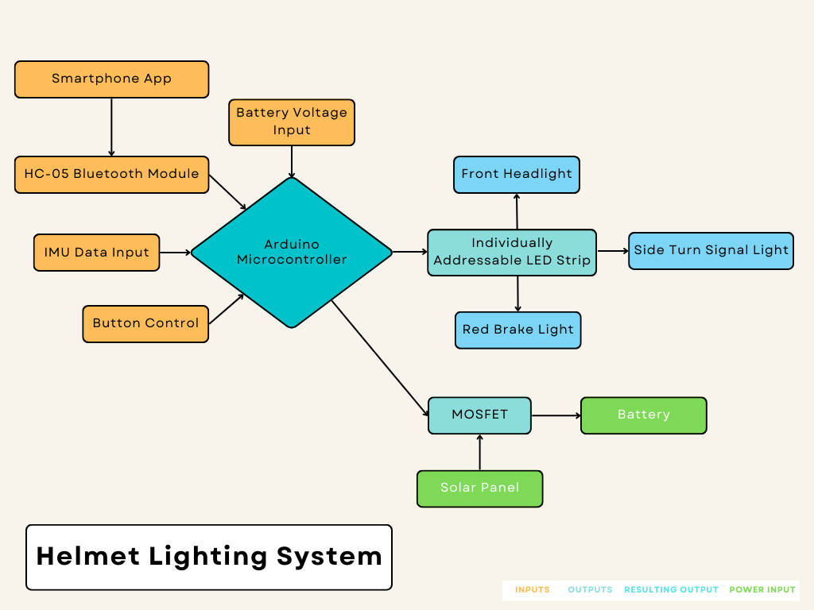

Topographic View Input Output View

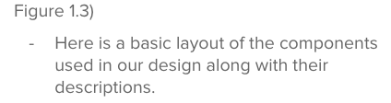

Base:

* 1x Bicycle Helmet
  + Retrospec Bike-Helmets Retrospec Dakota Bicycle Helmet - Commuter, Bike, Skate, Scooter, Longboard & Incline Skating - Shock-Absorbing, Highly-Protective & Premium Ventilation

Front:

* 1x Front Facing LED Strip
  + Here, on the front side of the helmet will be the left/right directional signals as well as the front facing headlight. This one strip can be individually addressable allowing one strip to do all three operations.

Rear:

* 1x Rear Facing LED Strip
  + Here, on the rear side of the helmet will be the left/right directional signals as well as the rear facing brake light. This one strip can be individually addressable allowing one strip to do all three operations.
* 1x Battery Cell
  + 3.7V 4000mAh 125050 Lipo Battery Rechargeable Lithium Polymer ion Battery Pack with JST Connector
  + Located at the rear of the helmet will hold the battery cell to store charge.

Left:

* 1x Black Box Controller Module
  + Dorhea MT3608 DC-DC Step Up Boost Power Converter 2A Module Adjustable Step Up Voltage Regulator Board Voltage 2-24V to 5V-28V Output Voltage Micro USB
  + HiLetgo Pro Micro Atmega32U4 5V 16MHz Bootloader IDE Micro USB Pro Micro Development Board Microcontroller Compatible to Arduino Pro Micro Serial Connection with Pin Header
  + KeeYees 4 Channels IIC I2C Logic Level Converter Bi-Directional Module 3.3V to 5V Shifter
  + Here located at the left side of the helmet will hold the controller consisting of the microcontroller board, logic level converter, development board and all physical control for the helmet. (on button/pairing button etc…)

Top:

* 1x IMU
  + Adafruit 9-DOF Absolute Orientation IMU Fusion Breakout - BNO055
    - Located at the top of the helmet; main sensor of motion, most ideal here centered on the head.
* 1x Solar Panel
  + Portable Flexible-Solar-Panel-Charger Small Solar Panels Wireless Charger 1 Watt 6 Volt Thin-Film-Roll-up-Bendable-Amorphous-Solar-Panel Cell
  + Located at the top of the helmet for optimal sun exposure, a solar panel for charging the helmet continuously during daylight usage.

Bill of material:

| Description | Link | QTY | Unit Cost | Shipping Cost | Total Item Cost |
| --- | --- | --- | --- | --- | --- |
| Adafruit 9-DOF Absolute Orientation IMU Fusion Breakout - BNO055 | <https://www.amazon.com/Adafruit-Absolute-Orientation-Fusion-Breakout/dp/B017PEIGIG/ref=sr_1_1?crid=2VP13DR0U95CW&keywords=imu&qid=1666589885&qu=eyJxc2MiOiI0LjU3IiwicXNhIjoiMy44OSIsInFzcCI6IjMuNjAifQ%3D%3D&sprefix=imu%2Caps%2C81&sr=8-1> | 1 | $33.99 | N/A | $35.19 |
| HiLetgo 3pcs GY-521 MPU-6050 MPU6050 3 Axis Accelerometer Gyroscope Module 6 DOF 6-axis Accelerometer Gyroscope Sensor Module 16 Bit AD Converter Data Output IIC I2C for Arduino | <https://www.amazon.com/HiLetgo-MPU-6050-Accelerometer-Gyroscope-Converter/dp/B00LP25V1A/ref=sr_1_3?crid=2EBOZXVNLNTBY&keywords=mpu%2B9265&qid=1670364795&sprefix=mpu%2B%2Caps%2C83&sr=8-3&th=1> | 1 | $9.99 | N/A | $9.99 |
| Portable Flexible-Solar-Panel-Charger Small Solar Panels for Science Projects Wireless Charger 1 Watt 6 Volt Thin-Film-Roll-up-Bendable-Amorphous-Solar-Panel Cell DIY for Car Camping Solar Charger | <https://www.amazon.com/Portable-Flexible-Solar-Panel-Charger-Projects-Wireless-Thin-Film-Roll-up-Bendable-Amorphous-Solar-Panel/dp/B08C7JQMFZ/ref=sr_1_8?crid=3GHBUAIRCSF9N&keywords=1+watt+6+volt+panel&qid=1666590321&sprefix=1+watt+6+volt+panel%2Caps%2C82&sr=8-8> | 1 | $9.99 | N/A | $9.99 |
| 3.7V 4000mAh 125050 Lipo Battery Rechargeable Lithium Polymer ion Battery Pack with JST Connector | <https://www.amazon.com/4000mAh-battery-Rechargeable-Lithium-Connector/dp/B07BTTV39D/ref=sr_1_7?crid=13IJPYKXCY1XH&keywords=lipo+battery+prismatic+4000&qid=1666590664&sprefix=lipo+battery+prysmatic+4000%2Caps%2C62&sr=8-7> | 1 | $17.99 | N/A | $17.99 |
| WS2812b 5V Individual Addressable LED Strip Light SMD5050 RGB Strip 3.2FT 144 Pixels/m 144 Pixels Black PCB Full Color LED Pixel Strip Non-Waterproof | <https://www.amazon.com/WS2812B-Individual-Addressable-144Pixels-Non-Waterproof/dp/B09PBGZMNS/ref=sr_1_5?keywords=ws2812b&qid=1666590916&qu=eyJxc2MiOiI1LjE4IiwicXNhIjoiNC45NyIsInFzcCI6IjQuODIifQ%3D%3D&sprefix=ws%2Caps%2C86&sr=8-5&th=1> | 2 | $12.99 | N/A | $25.98 |
| Retrospec Bike-Helmets Retrospec Dakota Bicycle/Skateboard Helmet for Adults - Commuter, Bike, Skate, Scooter, Longboard & Incline Skating - Shock-Absorbing, Highly-Protective & Premium Ventilation | <https://www.amazon.com/Retrospec-Dakota-Bicycle-Skateboard-Helmet/dp/B094PVJ875/ref=sr_1_8?keywords=helmet%2Badult&qid=1666591673&qu=eyJxc2MiOiI2LjcxIiwicXNhIjoiNi4zMiIsInFzcCI6IjUuNzYifQ%3D%3D&sprefix=helmet%2Bad%2Caps%2C80&sr=8-8&th=1&psc=1> | 1 | $26.99 | N/A | $26.99 |
| HiLetgo 3pcs TP4056 Type-c USB 5V 1A 18650 Lithium Battery Charger Module Charging Board with Dual Protection Functions | <https://www.amazon.com/HiLetgo-Lithium-Charging-Protection-Functions/dp/B07PKND8KG/ref=sr_1_8?crid=UYJZPD9NI7D9&keywords=lithium+battery+charge+usb&qid=1666591982&sprefix=lithium+battery+charge+usb%2Caps%2C64&sr=8-8> | 1 | $5.99 | N/A | $5.99 |
| HiLetgo 3pcs Pro Micro Atmega32U4 5V 16MHz Bootloader IDE Micro USB Pro Micro Development Board Microcontroller Compatible to Arduino Pro Micro Serial Connection with Pin Header | <https://www.amazon.com/HiLetgo-Atmega32U4-Bootloadered-Development-Microcontroller/dp/B01MTU9GOB/ref=sr_1_8?crid=2HWDQQ8D88WUN&keywords=arduino+pro+micro+3.3v&qid=1668573563&s=electronics&sprefix=arduino+micro+3%2Celectronics%2C107&sr=1-8> | 1 | $24.49 | N/A | $24.49 |
| Dorhea MT3608 DC-DC Step Up Boost Power Converter 2A Module Adjustable Step Up Voltage Regulator Board Voltage 2-24V to 5V-28V Output Voltage Micro USB (Pack of 10) | <https://www.amazon.com/Converter-Adjustable-Voltage-Regulator-Compatible/dp/B089JYBF25/ref=sr_1_3?crid=29XBRD7YUNMCC&keywords=boost%2Bconverter&qid=1668574613&sprefix=BOOST%2BCON%2Caps%2C78&sr=8-3&th=1> | 1 | $9.99 | N/A | $9.99 |
| DSD TECH HM-10 Bluetooth 4.0 BLE iBeacon UART Module with 4 PIN Base Board for Arduino UNO R3 Mega 2560 Nano | <https://www.amazon.com/DSD-TECH-Bluetooth-iBeacon-Arduino/dp/B06WGZB2N4> | 1 | $10.99 | N/A | $10.99 |
|  |  |  |  | TOTAL | $177.59  +  Tax & shipping |

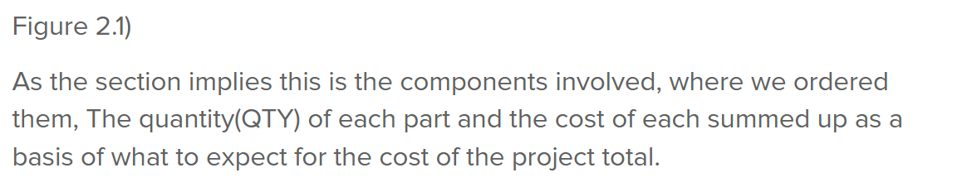

Scheduling/Gantt Chart: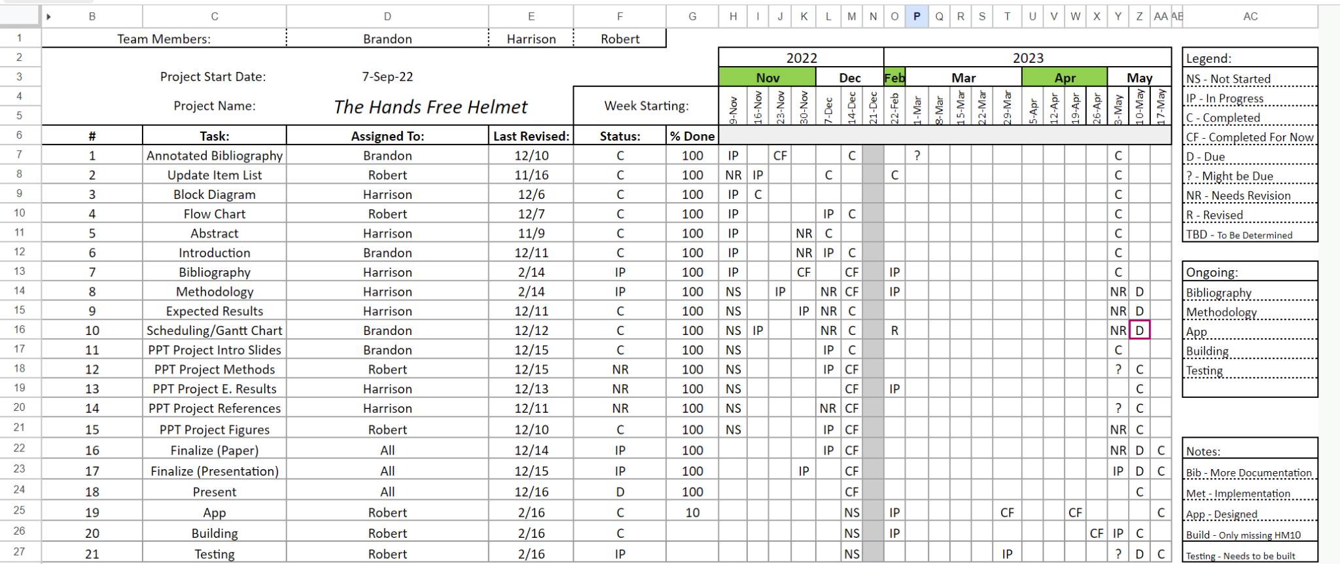

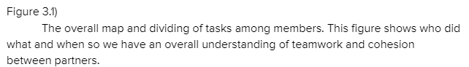

The scheduling involved with this paper was split among main categories, and of course with reassurance of if anyone needed help we can switch roles. Robert being the most experienced with electronics would do most of the research involving the coding and the electronics parts. Robert was in charge of the thinking of how all of these parts are going to work together and in terms of the paper would be in charge of the methodology of the creation of the device and the expected results. Harrison and Brandon were both in charge of finding references and writing mostly. The resources were shared between everybody and to make them easily understandable an Annotated Bibliography was made to understand what is to be expected of each source, making them easier to interpret and incorporate. Harrison took more charge with writing the details in the Abstract as well as anything visual, he also took initiative to revise the sections of the writing. Brandon was in charge of the project management duties and the paper in the ways that were left over.

Design Process:

Beginning with our initial layout described in our flowchart and block diagram, we wanted to achieve a completely hands off operation and minimal interaction overall. In order to achieve this we knew we would need devices to collect motion data. So we began sourcing gyroscopic devices and decided on an IMU. This allows us to generate data within a 3D space which directly leads to our main function being to signal and brake without using your hands. Our other features such as the solar pad allows less time on a charger and a longer lasting experience and the use of an app as a backup in the event something were to not function properly. Once properly mapped, we ordered all components and began piecing it together.

Once all the components were delivered we tested each one for any defects or conflicting issues, as well as replaced components when needed. This was only needed for the Solar Panel and the IMU. We wanted to split the process in order to ensure we can pinpoint any flaws as we continue so, each component was tested, designed, and programmed independently in such a way that the variables can easily be mapped onto a final all-inclusive program. The coding was first drafted to work with our parameters along with compatibility across components as a system. Once our individual components were functioning, we then could calibrate and tune them to work with one another and make our proof of concept. The final list of variables goes as followed in the figure below, for more check out the [github](https://github.com/BrandonMichael493/SeniorDesignHandsFreeHelmet) link to the project.

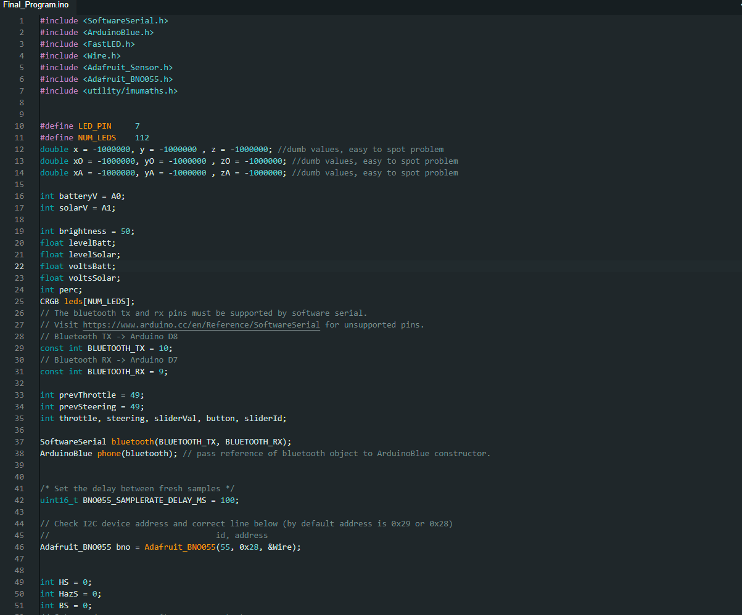

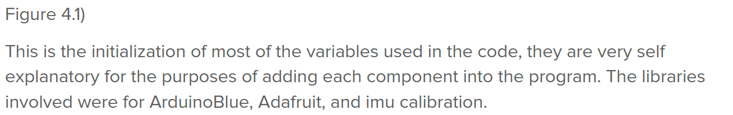

After we had all the variables initialized and implemented the code from the individual tests we added a setup code to allow us to see if the software is properly connected to the hardware, and started work on the design of how the functions will work together. The code starts with the orientation and calibration of the IMU, followed by setting up the app and its GUI. When the sliders and buttons are all set up there's code to check the Battery as well as the solar charging capabilities. If the power from the sun is too little (IE: it is very dark out) the headlamp is set to turn on for visibility's sake. After the code was all tidied up and compiled it was time to make the PCB.

Now to package our system to fit into the standardized helmet we would design our own custom PCB and assembly the components to that. This would mean we would also end up designing a casing to fit the PCB into for isolating the electrical parts from the Bicycle Helmet itself, this will be provided in Figure 4.2 below the paragraph. This casing had to be big enough to isolate the components and small enough to fit in the width of the helmet as well as have access to the charging port so the user can charge the helmet via USB-C override, The stl files will be shown in Figure 4.4 and 4.5 below the paragraph. Lastly, was to test our design in the real world to adjust and tweak any flaws.

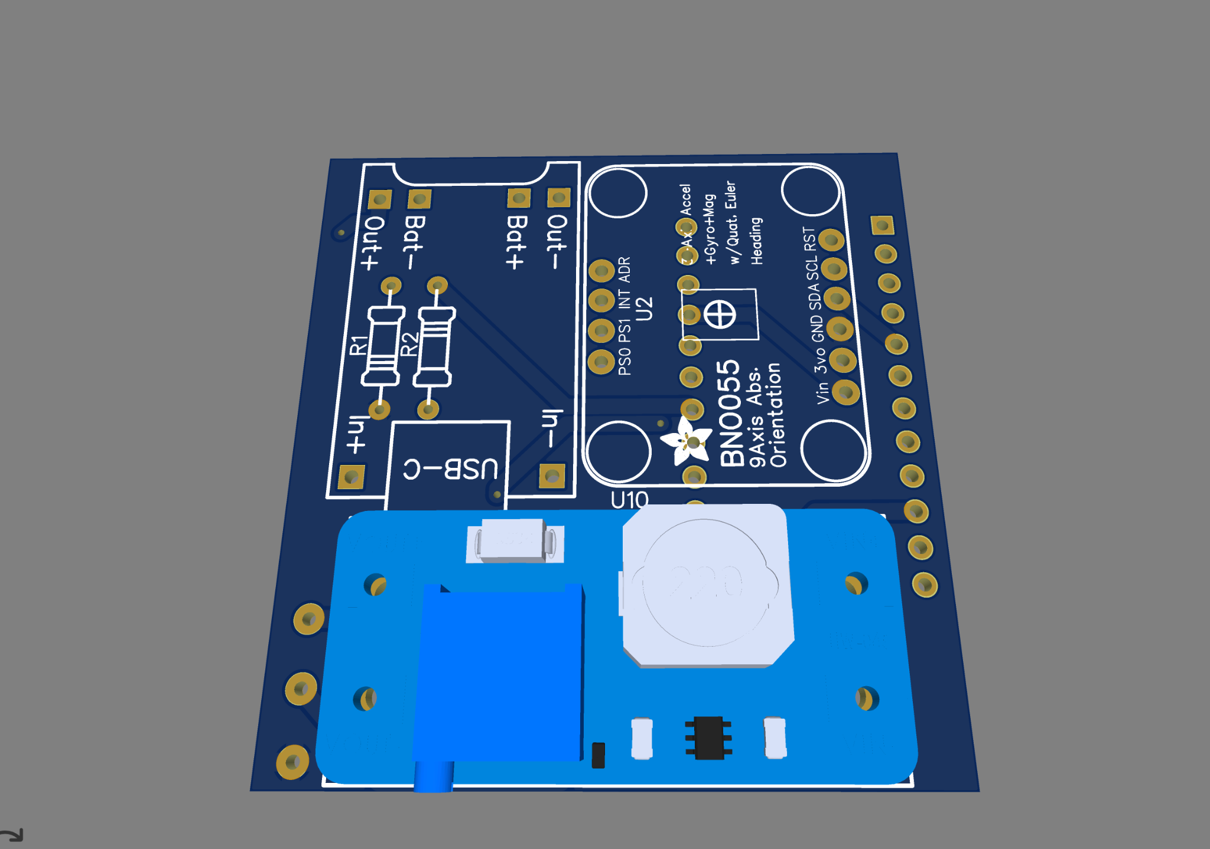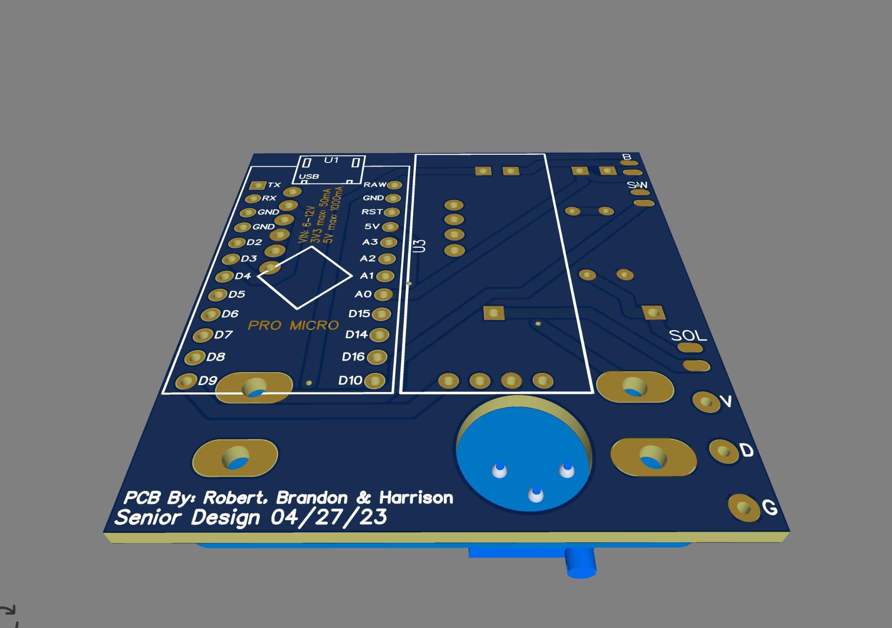

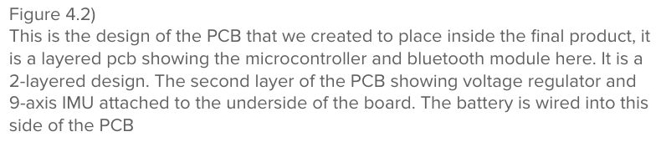

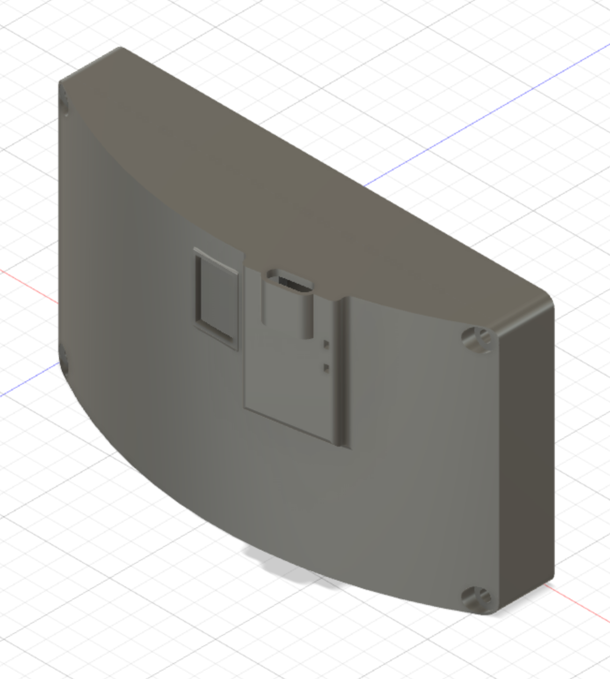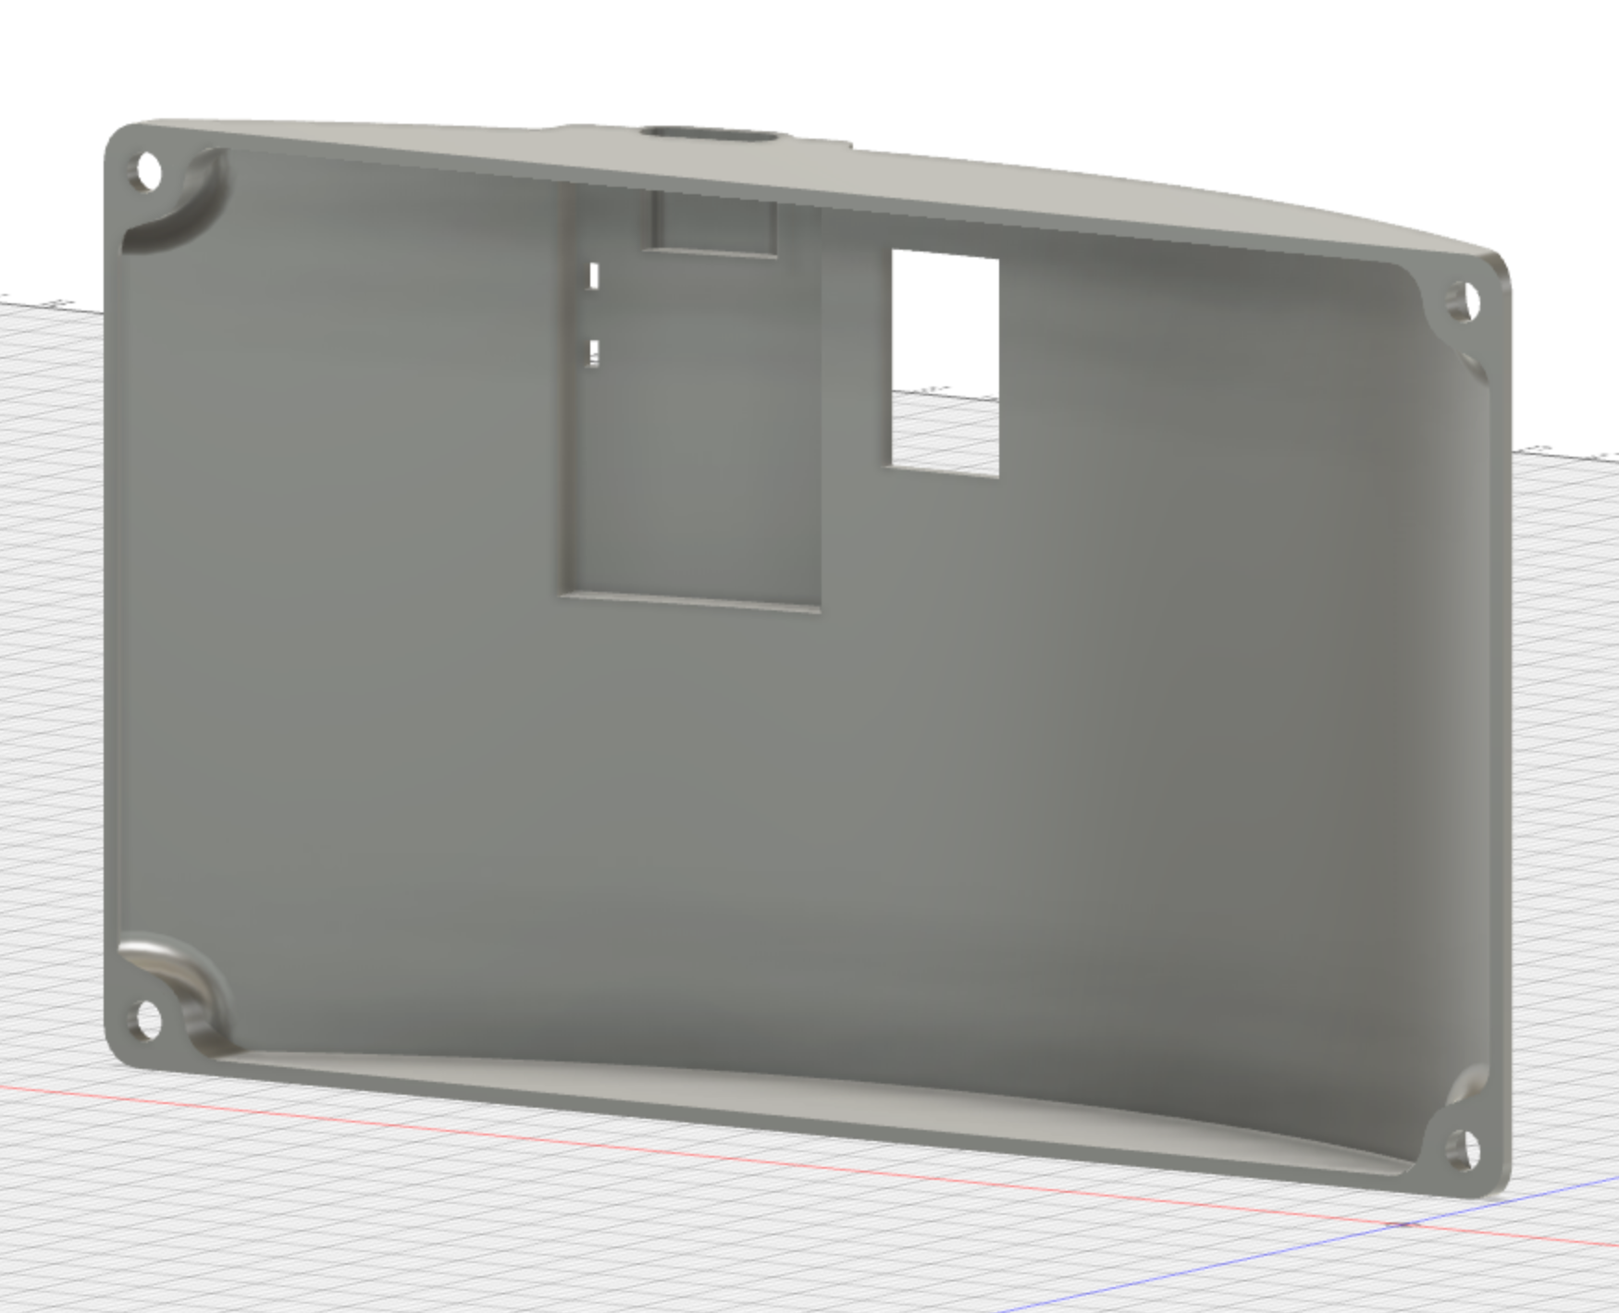

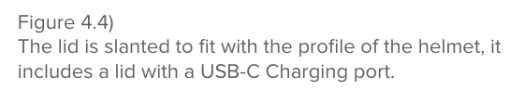

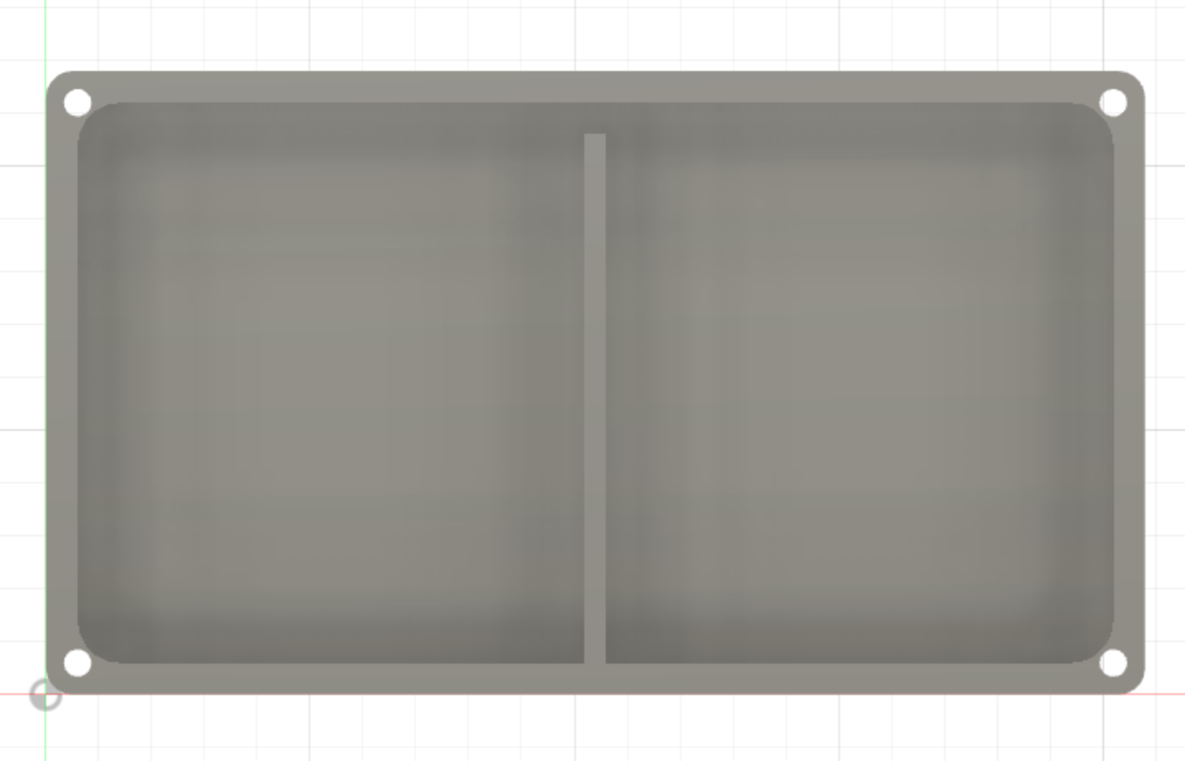

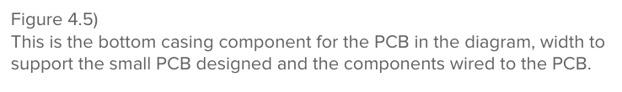

Expected Result:

Upon assembling all the components and making all the software features work correctly the helmet can power on and start collecting IMU data. From here, several actions take place with the data gathered from the IMU. When deceleration is detected, the illumination of the rear red light triggers on as long as the deceleration is occurring thus, giving us our brake light. Then the helmet illuminates the left or right side; front and rear, LEDs in yellow when a tilt of a certain angle is detected. This activates the turn signals for a full 15 seconds when triggered. The helmet also has a connection to a companion app that displays the approximate battery percentage and allows adjustment of the brightness of all the LEDs on the helmet. The app can also manually control the LEDs including the headlight, brake light, turn signals, and hazard function. In the same fashion the IMU provides both brake and turn signals, the buttons can be pressed in an app as a backup if the primary motion system fails. Also from the app, the user can monitor the solar charging efficiency as well as a ‘syncing’ function to properly connect and calibrate the helmet to your smart device. In the case of a high g-force impact to the helmet such as a sudden fall, a “hazard” function will activate in order to illuminate the wearer to others like traffic that the rider has experienced an abnormal impact to the head. This “hazard” function being all LEDs flashing in 2 second intervals for maximum visibility to the third party. Our design is a robust helmet with all of the above mentioned features, along with a decent battery life span between charges and efficient charging. With this implementation we have brought a more intuitive and simplistic solution to the cycling consumer market.

Result:

As a result of this project being on the simpler side, all of the functions worked in the end. The tricky part is calibrating the gyroscope to do all main functions properly. The issue we were unable to properly get functioning was making the gyroscope functionalities act 100% consistent. Even at the highest calibration level, unless it was calibrated completely properly it would struggle to find its whereabouts in 3d space. However, The app functionality includes all of the brightness controls and the battery level and solar panel capabilities. Due to time constraints we had issues with bringing the helmet into fruition, but we have a casing that fits inside the bicycle helmet and fits with the LED strip around it. The helmet looks great and the IMU detects deceleration easily enough, allowing us a properly functioning brake light. When the helmet is calibrated very carefully and deliberately, the Left and Right turn signals work properly and showcasing the program reading the data correctly. Also the Headlight turns on whenever the voltage coming from the Solar panel is low enough, meaning that when it is dark outside the headlight will turn on automatically at the brightness it was set to previously. The app also has a way to check the battery life and the charge coming from the solar panel through commands. The app works perfectly, lending it as a great companion for if the gyroscope functions don’t want to work properly. Lastly, the “hazard” function is implemented and it shows all LEDs flashing in 2 second intervals for maximum visibility to the third party. Our design is a robust helmet with all of the above mentioned features, along with a decent battery life span between charges and efficient charging. Pictures of the final project in question are shown below.

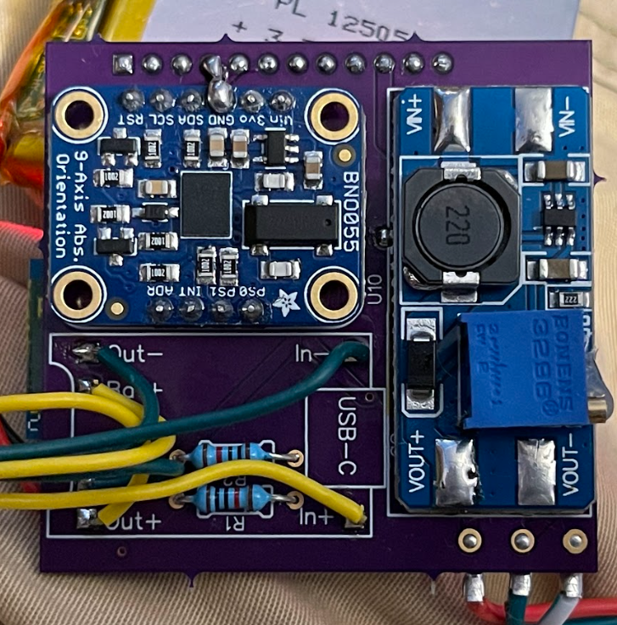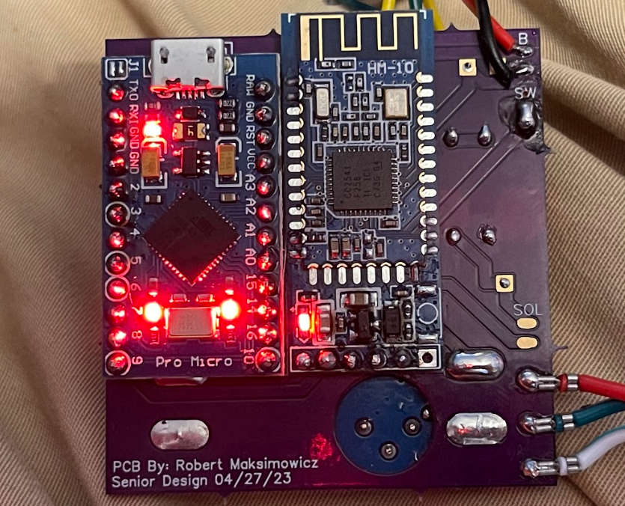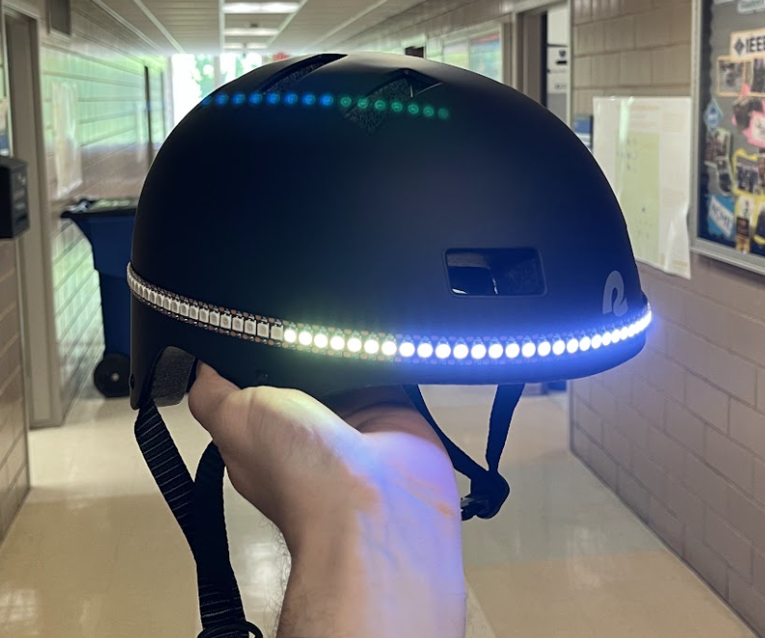

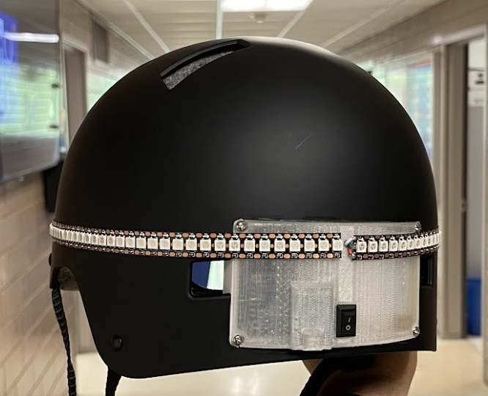

Fig 4.6)

Pictures of the Project: This is the final result of our hard work, and can be attached onto onto the helmet via the 3d printed casing

References:

* [1]*ArduinoBlue*. Google Sites: Sign-in. (n.d.). Retrieved May 4, 2023, from <https://sites.google.com/stonybrook.edu/arduinoble/#h.p_TqD1cnyO-TO2> [Accessed: 4-May-2023].
* [2] Department of Transportation (DOT). “Bicycle Crash Data Report - New York City,” *Bicycle Crash Data Report 2020*. [Online]. Available: <https://www1.nyc.gov/html/dot/downloads/pdf/bicycle-crash-data-report-2020.pdf>. [Accessed: 10-Dec-2022].
* [3]Department of Transportation, “Bicycle Safety,” *NHTSA*, 2018. [Online]. Available: <https://www.nhtsa.gov/road-safety/bicycle-safety> . [Accessed: 15-Dec-2022].
* [4]*How much CO2 does cycling really save?* ECF. (2021, April 22). Retrieved May 5, 2023, from <https://ecf.com/news-and-events/news/how-much-co2-does-cycling-really-save> [Accessed: 5-May-2023].
* [5] A. Benepe, T. R. Frieden, R. W. Kelly, and I. Weinshall, “Bicyclist fatalities and serious injuries in New York City,” *Bicyclist Fatalities and Serious Injuries New York City*. Oct-2009[Online]. Available: <http://www.nyc.gov/html/dot///downloads/pdf/bicyclefatalities.pdf>. [Accessed: 10-Dec-2022].
* [6] J. Mandel-Ricci, C. Stayton, L. Nicaj, S. Assefa, D. Woloch, K. Jeffrey, P. McCarthy, and N. Budnick, “A multiagency effort to reduce bicyclist fatalities and serious injuries in New York City,” *Public health reports (Washington, D.C. : 1974)*, Sep-2008. [Online]. Available: <https://www.ncbi.nlm.nih.gov/pmc/articles/PMC2496939/>. [Accessed: 10-Dec-2022].
* [7] R. Thompson, F. Rivara. D. Thompson; “A case-control study of the effectiveness of bicycle safety helmets,” *The New England journal of medicine*, 25-May-1989. [Online]. Available: <https://pubmed.ncbi.nlm.nih.gov/2716781/>. [Accessed: 10-Dec-2022].
* [8] D. Roe and D. Jackson, “Drivers are making more mistakes... and killing more New York cyclists,” *Bicycling*, 11-Mar-2021. [Online]. Available: <https://www.bicycling.com/news/a31122171/nyc-cycling-crash-data/>. [Accessed: 10-Dec-2022].
* [9] J. C. Reiter, “Bicycle accident injuries in New York City update 2021 by New York City bicycle accident lawyer Jonathan C. Reiter,” *GlobeNewswire News Room*, 23-Feb-2021. [Online]. Available: <https://www.globenewswire.com/en/news-release/2021/02/23/2180836/0/en/Bicycle-Accident-Injuries-in-New-York-City-Update-2021-by-New-York-City-Bicycle-Accident-Lawyer-Jonathan-C-Reiter.html>. [Accessed: 10-Dec-2022].
* [10] J. C. O. Madsen, T. Andersen, and H. S. Lahrmann, “Safety effects of permanent running lights for bicycles: A controlled experiment,” *Accident Analysis & Prevention*, vol. 50, pp. 820–829, 2013.
* [11] J. Walljasper, “10 reasons bicycling will continue to soar in popularity,” *Strong Towns*, 19-Feb-2018. [Online]. Available: <https://www.strongtowns.org/journal/2018/2/9/12-reasons-bicycling-will-continue-to-soar-in-popularity>. [Accessed: 10-Dec-2022].
* [12] Kevin Glenton. “Best bike helmets with lights built-in [top 6],” Discerning Cyclist, 10-Nov-2022. [Online]. Available: <https://discerningcyclist.com/best-bike-helmets-with-lights-built-in/#lumos>. [Accessed: 11-Dec-2022].
* [13] VectorNav. “What is an inertial measurement unit?,” *VectorNav*. 2010 [Online]. Available: <https://www.vectornav.com/resources/inertial-navigation-articles/what-is-an-inertial-measurement-unit-imu?gclid=CjwKCAiAvK2bBhB8EiwAZUbP1BdmJvL5DiYV3EuZJFfK2G6akUy2WY4xkWOgVw7X_Sd5P7GGKFf6BRoCBs0QAvD_BwE>. [Accessed: 10-Dec-2022].
* [14] A. Küderle, “Imucal,” *PyPI*, 17-Oct-2022. [Online]. Available: <https://pypi.org/project/imucal/>. [Accessed: 10-Dec-2022].